

CENTENNIAL COLLEGE PROGRESS CAMPUS

COURSE COMP229 Winter 2017 – Midterm Exam

**Implementation**

This is the how we should define our Default page:

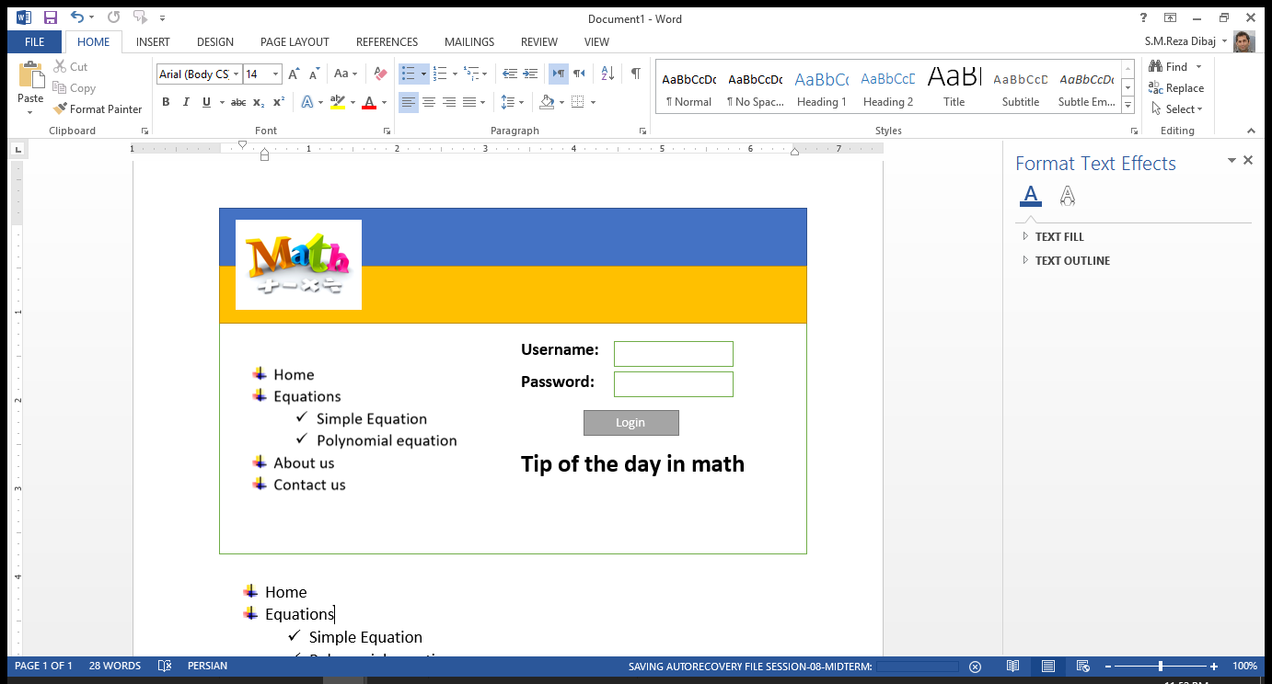

**Implementation steps:**

1. Provide a Site Map that contains the above site structure.
   1. add two subdirectory to Equations:
      1. Simple Equation
      2. Polynomial equation

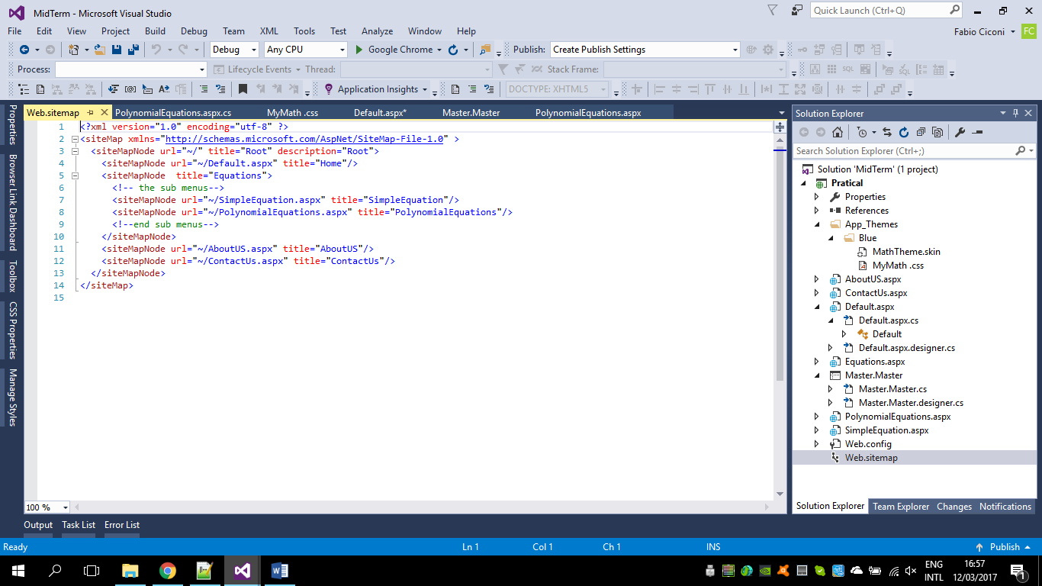

1. Create separate aspx file for each item in the above menu

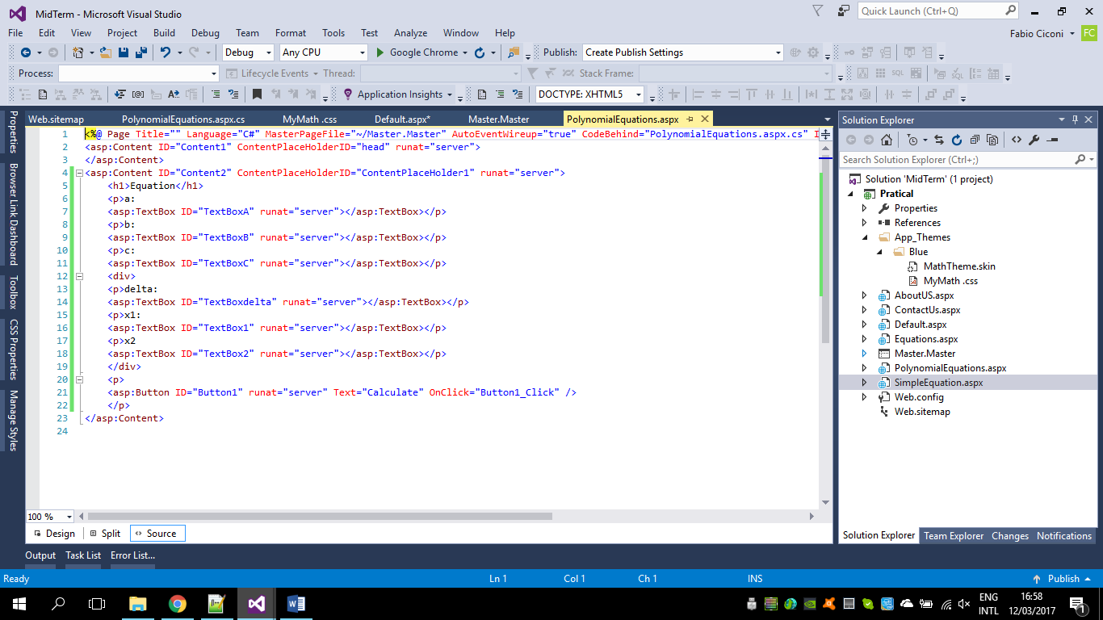

1. In Polynomial equation webpage, please provide three textboxes to receive a, b and c from the user and calculate X1 and X2.

**Hint:** You have to define a function to calculate the following equation. You can use similar approach that you had for factorial calculation.



 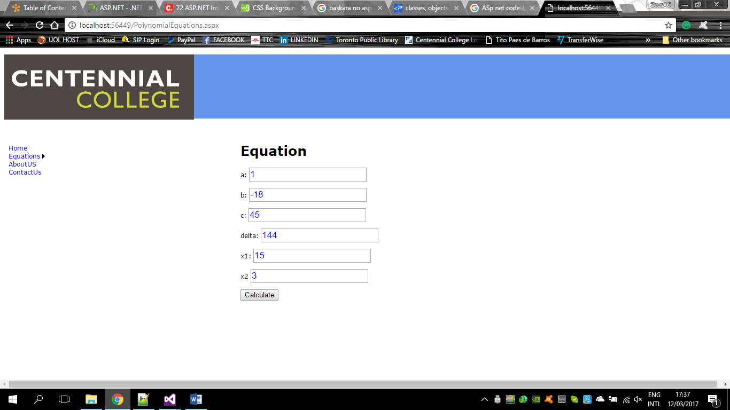

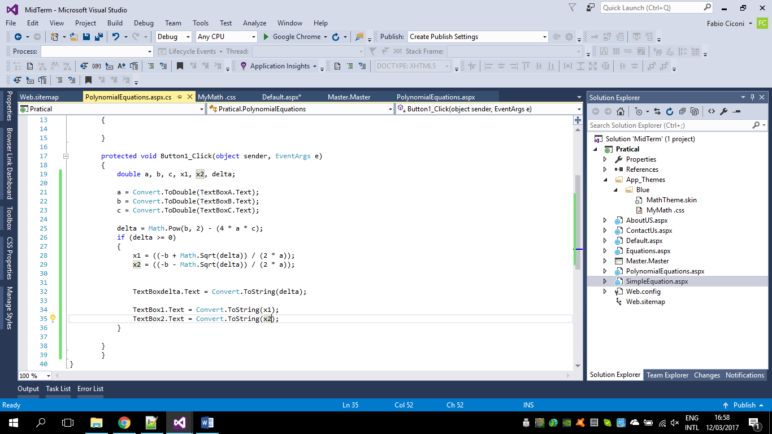

1. Create a **App_Themes** folder in the **Solution Explorer** and add **MathTheme** as a New Item there.

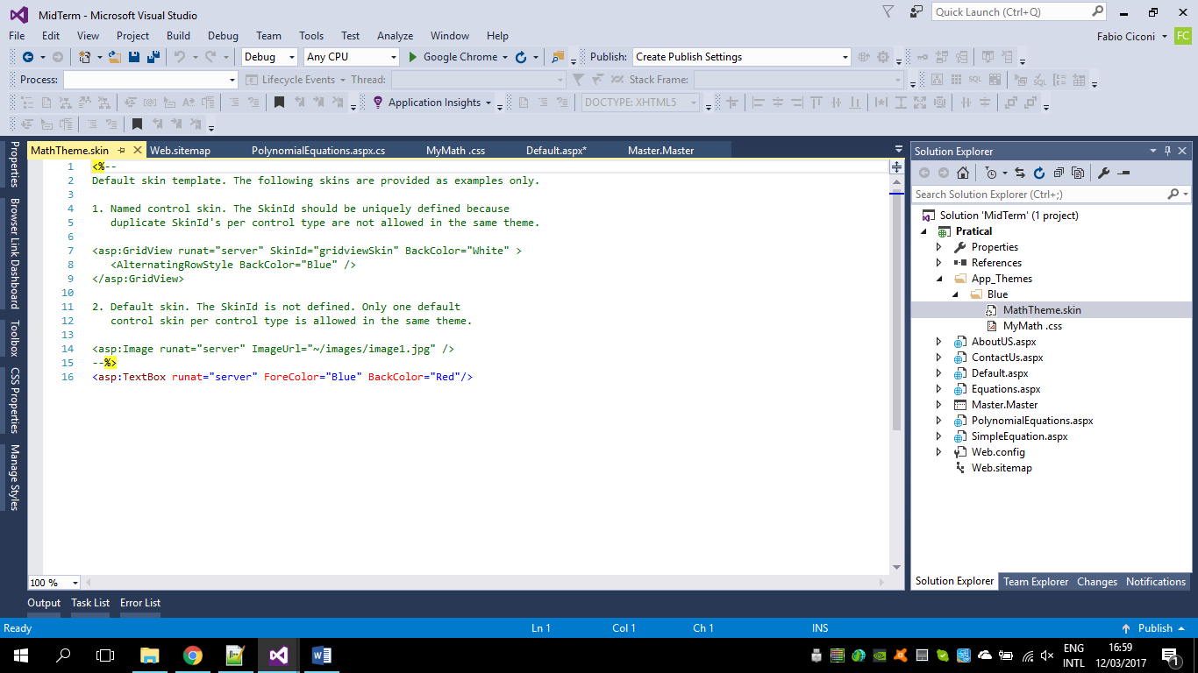

1. Create a style sheet there and name it **MyMath** and define an appropriate style in it.

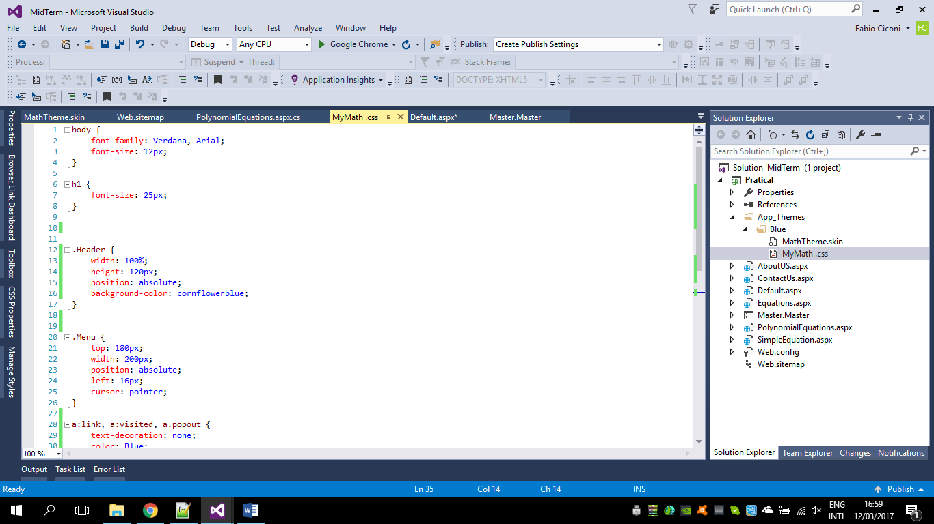

1. Define a skin for your Server Control textboxes as the font, forecolor and back color are defined differently from the default.

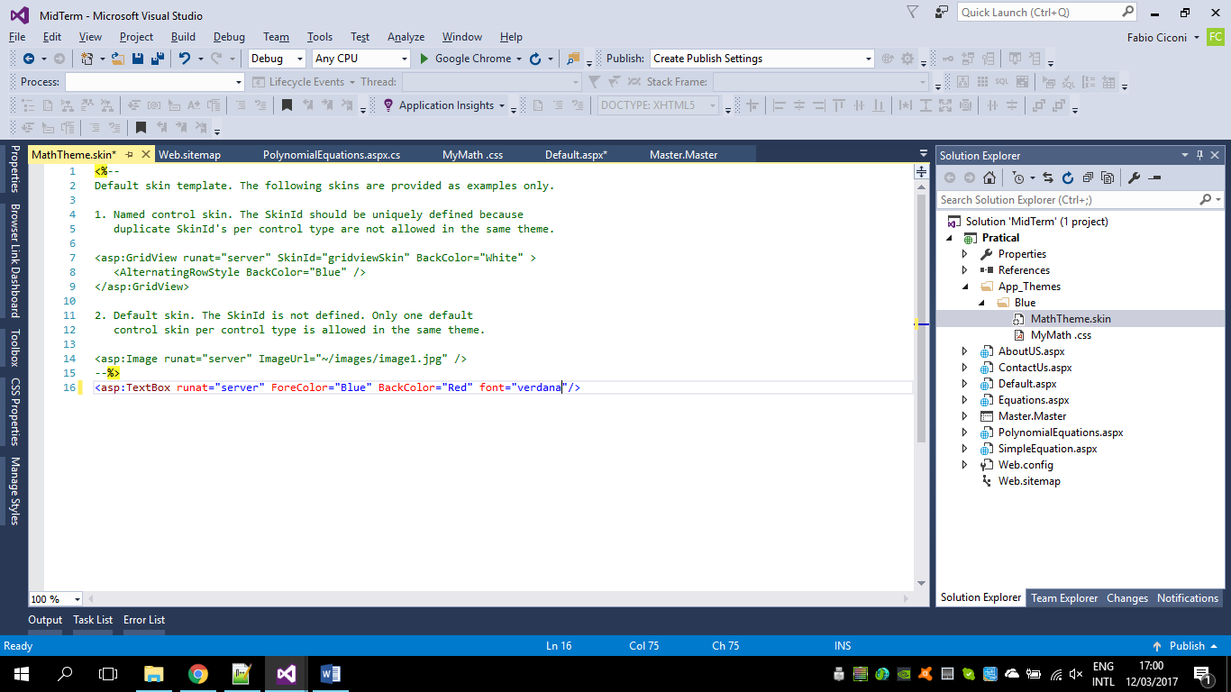

1. **IMPORTANT:** Explain how to connect your skin and your text boxes together.
2. Explain what is the main difference between CSS and Skin?

To connect text box and skin is necessary to write a command in the web config file. If you do not use SkinID command the code on the skin will be applied to all controls.

<asp:TextBox runat="server" Forecolor= "Blue" Backcolor="Green" Font-Size="17px" Font-Name="Arial"/>

All textboxes will be the same attributes above.

Skin file can be used on ASP.NET server controls.

CSS is used in HTML elements

Skin is rendered from ISS server is unique for all clients;

CSS is rendered on the client side, so some browsers may present issues;

1. Define a master page that contains header, menu and a content section. Define an appropriate image for the header and the menu items.

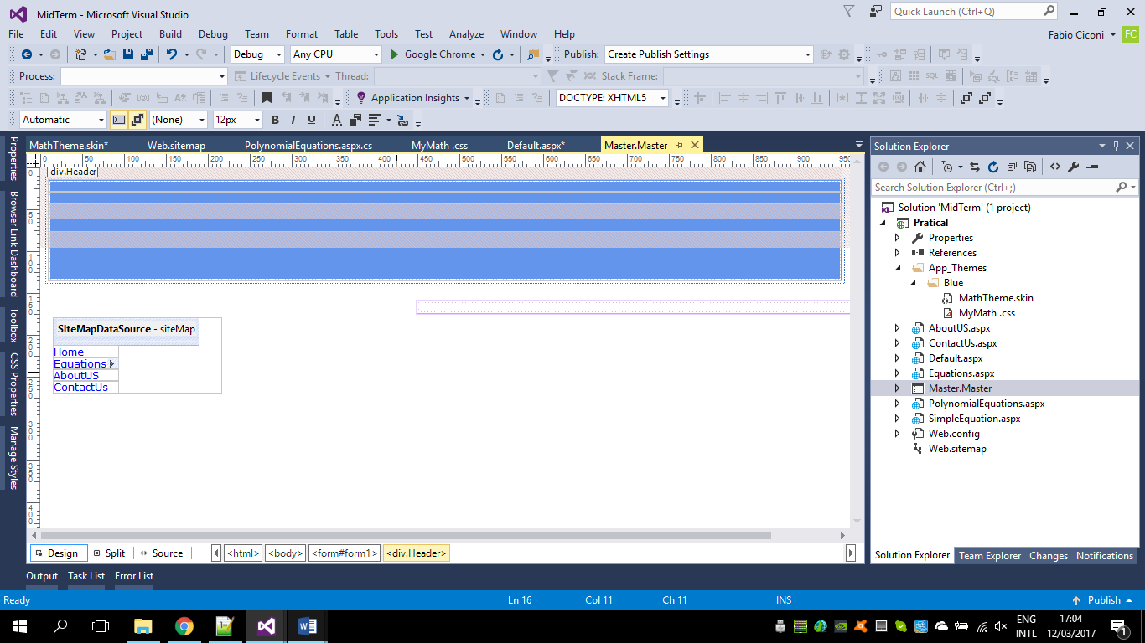

1. Explain how to hide the root in the menu

To hide the root menu is used the command ShowStartingNode="False";

**NOTE:**

**Define each step of the above sections separately in your MS Word Document.**

**Questions**

**Question 1:**

1. What is ViewState?

It a technique that Asp .net use to preserve page and control values

between postbacks.

1. Where the viewstate is stored after the page postback?

ViewState is stored in a hidden field on the page at client side.

c) How long the items in ViewState exists?

View State exist for the life of the current page.

**Question 2:**

What is the role of Directives in ASP.NET code? What did you use them for? What were problems that you faced when you wanted to use Directives? What was your solution for them?

Directives specify settings that are used by the page and user-control compilers when the compilers process ASP.NET Web Forms pages (.aspx files) and user control (.ascx) files

ASP.NET treats any directive block (<%@ %>) that does not contain an explicit directive name as an @ Page directive (for a page) or as an @ Control directive (for a user control).

**Question 3:**

When do we use server-side comments and when do we use the client side comments?

What can happen if we misuse them and what could we receive as potential error? What is your solution for it?

-client-side comments (<!-- -->), which you can use to prevent a browser from parsing/running/displaying the HTML content within it.

The problem is that the content contained within the comment is still sent down from the server to the client unnecessarily and the server-side code within the comment will still execute on the server.

**Question 4:**

Why in some languages we need to define variables at the beginning of the code and why we do not need to do so in some others? When should we use global variables and when should be use local ones? Why? Which one do you pick as your default?

Some languages are procedural and its need to be declared in sequence defined

Global variable - declared at the start of the program, their global scope means they can be used in any procedure or subroutine in the program;

Local variable - declared within subroutines or programming blocks, their local scope means they can only be used within the subroutine or program block they were declared in.

As a default I used to global variables.

**Question 5:**

Briefly define the following concepts in Object Oriented Programming:

objects:  Object is a class to be instantiated

properties: properties are characteristics shared by all objects of a particular

class.

methods: Methods are actions that objects of the class can be told to perform.

classes: class to house the set of methods that perform the

class’s tasks. For example, a class that represents a bank account might contain one method

to deposit money to an account,

scope: Scope means that the method or variable may or may not be directly accessable to other objects or classes

events: events occur when a control object sends a message as a result of some change that has been made to it.

inheritance: refers to the ability of a specialized class to refine the properties

and methods exposed by another, more generalized class

**Question 6:**

Which one do you prefer to use, a code-behind or <scrip>? What are the pros and cons of each of them?

I rather use code-behind in my opinion is easier to follow and organize the code. his allows a clean separation of your HTML from your presentation logic

Pro- we can separate design and the codification part;

**Question 7:**

Suppose you want to link to a webpage using one of the following controls. Which one are you going to use and why? Which one did you have difficulty when you wanted to use?

* Button
* ImageButton
* LinkButton
* HyperLink

I would probably use the Linkbutton option, because it has appearance of hyperlink but still has the functionality of a button .Depend on the scenario it is used as a hyperlik.

**Question 8:**

Explain about application state, session state and cache object. Explain the cases that we should use any of these types. What can we use instead of cache object between application state and session state?

Application state is a data repository available to all classes in an ASP.NET application

Cache: The Cache can be thought of as the memory. It is simply, the memory of the machine/server

from which the source code is running

Session: A session is defined as a period of time that is shared between the web application

and the user.

**Short Questions**

**Short Question 1:**

List the events in page life cycle.

[PreInit](https://msdn.microsoft.com/en-us/library/system.web.ui.page.preinit.aspx), [InitComplete](https://msdn.microsoft.com/en-us/library/system.web.ui.page.initcomplete.aspx), [PreLoad](https://msdn.microsoft.com/en-us/library/system.web.ui.page.preload.aspx), [Load](https://msdn.microsoft.com/en-us/library/system.web.ui.page.preload.aspx), Control events, [LoadComplete](https://msdn.microsoft.com/en-us/library/system.web.ui.page.loadcomplete.aspx), [PreRender](https://msdn.microsoft.com/en-us/library/system.web.ui.control.prerender.aspx), [PreRenderComplete](https://msdn.microsoft.com/en-us/library/system.web.ui.page.prerendercomplete.aspx), [SaveStateComplete](https://msdn.microsoft.com/en-us/library/system.web.ui.page.savestatecomplete.aspx), [Render](https://msdn.microsoft.com/en-us/library/system.web.ui.control.render.aspx), [Unload](https://msdn.microsoft.com/en-us/library/system.web.ui.control.unload.aspx)

**Short Question 2:**

Can we have a web application running without web.Config file?**Yes/No**

Yes we can run asp.net application without web.config file

**Short Question 3:**

What is the good practice to implement validations in aspx page? Client side validation or server side validation? Why?

Client-side, because reduces the network traffic and saves server resorce

**Short Question 4:**

Which protocol is used to call a Web service?

SOAP. (Simple Object Access Protocol).

**Short Question 5:**

Can we have multiple web config files for an asp.net application? Yes/No

Yes, You can place a more than one web.config file in the sub-directory and ASP.NET will override

**Short Question 6:**

What is the difference between web config and machine config?

machine.config file is the master configuration file on your system with a lot of default settings.

Web.config is the file for the local settings to be applied for a website

**Short Question 7:**

In which event are the controls fully loaded?

Page load event

**Short Question 8:**

What is the difference between an *HtmlInputCheckBox* control and an *HtmlInputRadioButton* control?

HtmlInputCheckBoxcontrol, possible  multiple  item selection, HtmlInputRadioButton  only one item selected.

**Short Question 9:**

What is actually returned from server to the browser when a browser requests an .aspx file and the file is displayed?

When a browser requests an .aspx file then the server returns a response, which is rendered into a HTML string.

**Short Question 10:**

What is the difference between authentication and authorization?

authentication: is the process of verifying who you are. When you log on to a PC with a user name and password you are authenticating.

authorization: is the process of verifying that you have access to something. Gaining access to a resource (e.g. directory on a hard disk) because the permissions configured on it allow you access is authorization.

**Short Question 11:**

What does the Orientation property do in a Menu control?

Can display the Menu on webpage horizontal or vertical position

**Short Question 12:**

What is the use of PlaceHolder control? Can we see it at runtime?

The PlaceHolder control lets us add elements at a particular place on a page at any

time, dynamically, through our code.

Yes you can see at run time.

**Short Question 13:**

Web forms are inherited from which class?

All Web Form pages inherit from a base class: System.Web.UI.Page and all Web Form controls inherit from a common base class: System.Web.UI.WebControls class.

**Short Question 14:**

What is the use of hidden field? Briefly explain it with an example:

The HiddenField control is used to store a value that needs to be persisted across posts to the server.

We can use to:

storing data in a session server-side;

**Short Question 15:**

Briefly explain about Global.asax. Why should we use this file?

Is an optional file that contains code for responding to application-level events raised by ASP.NET or by HttpModules. It

defines subroutines that are executed in response to application-wide events. For

instance, Application_Start is executed the first time the application runs (or just

after we restart the server).

All my best, and wish you the best of luck ☺

Reza

**The wound is the place where the Light enters you.**

**~Rumi**